**QUESTION 1.**

1. **Identify actor.**

Dog’s owner.

Vets.

Senior Vet.

The AIK9 existing website.

1. **Functional user requirement**

**Dog’s owner**

Dog’s owner shall be able to create a new support case for their own dog.

Dog’s owner shall be able to add a comment to a case, except it is deleted case.

Dog’s owner must provide short description of the problem to each of their comment

Dog’s owner must provide long description of the problem to each of their comment

Dog’s owner shall be able to add attachments to each of their comment

Dog’s owner shall be able to see the status of their case

Dog ‘s owner shall be able to see all vet personal case’s note

Dog’s owner shall be able to view completed cases for their dog in case history

**Vets**

Vet shall be able to see list of his/her Open cases in their personal queue.  
Vet shall be able to see list of his/her Stalled cases in their personal queue.

Vet shall be able to see list of all New cases from the clinic queue

Vet shall be able to pick a New case from the clinic queue

Vet shall NOT be able to un-open a New case

Vet shall be able to give their Open case to another vet

Vet shall be able to add comments to their Open case

Vet must provide short description of each comment to their Open case

Vet must provide long description of each comment to their Open case

Vet shall be able to add attachments to each comment of their Open case

Vet shall be able to resolve an Open case

Vet shall be able to Close an Open case

Vet shall be able to re-Open their own Resolved cases.

Vet shall be able to re-Open their own Closed cases.

Vet shall be able to search all cases of a specific dog model via the case history, except Deleted case

Vet shall be able to search all cases of a specific dog via the case history, except Deleted case

Vet shall be able to view all cases via the case history, except Deleted cases .

**Senior Vet** (Senior vet has inheritance relationship with Vet. Senior vet shall be able to do whatever Vet can do)

Senior Vet shall be able to delete a New case

Senior Vet shall be able to view current Open cases of all other currently employed vets.

Senior Vet shall be able to view current Stalled cases of all other currently employed vets.

Senior Vet shall be able to view the total number of cases Resolved by each vet in the current month

Senior Vet shall be able to view the total number of cases Resolved by each vet in the last month

Senior Vet shall be able to view the total number of cases Resolved by each vet in the current week

Senior Vet shall be able to view the total number of cases Resolved by each vet in the last week

Senior Vet shall be able to view the total number of cases Closed by each vet in the current month

Senior Vet shall be able to view the total number of cases Closed by each vet in the last month

Senior Vet shall be able to view the total number of cases Closed by each vet in the current week

Senior Vet shall be able to view the total number of cases Closed by each vet in the last week

**The AIK9 existing website.**

The AIK9 existing website shall be able to assign each dog’ owner with a unique owner name

The AIK9 existing website shall be able to assign each vet with a unique employee number

The AIK9 existing website shall be able to authenticate owner’s user identification and password when a dog’s owner login the system

The AIK9 existing website shall be able to authenticate vet’s user identification and password when a vet login the system

The AIK9 existing website shall be able to notify dog owner when a vet comment on the owner’s case

The AIK9 existing website shall be able to notify a vet when a dog owner adds a new comment on his/her case.

**QUESTION 2.**

1. **Use case Diagram**

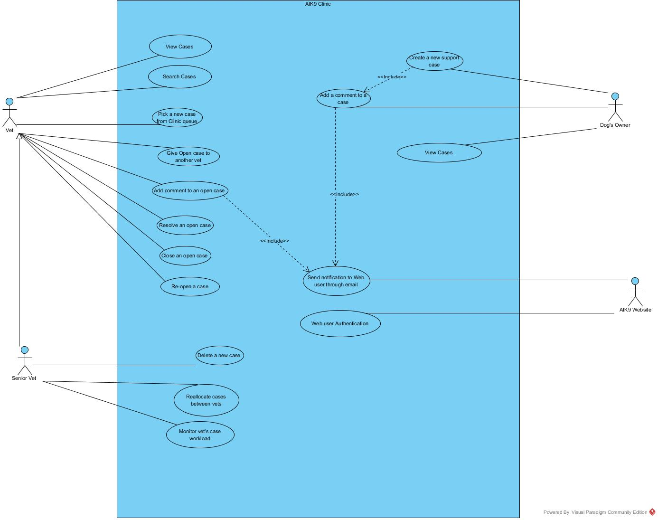

1. **Fully dressed use case**

|  |  |  |  |
| --- | --- | --- | --- |
| Use Case Identification and History | | | |
| Use Case ID & Name: | UC1: Create new support case | Version: | 1.1 |
| Objective: | Dog owner create a new support case in the AIK9 Clinic | | |
| Created by: | MY PHU NGUYEN 16933824 | Date: | 09/04/2018 |
| Actors & Goals: | Dog owner: create a new support case in the AIK9 Clinic  The AIK9 existing website: display a list of dogs owned by the owner  Vet: view the new support case via AIK9 Clinic Queue | | |
| Stakeholders | Dog owner: create a new support case in the AIK9 Clinic  The AIK9 existing website: display a list of dogs owned by the owner  Vet: view the new support case via AIK9 Clinic Queue  Senior vet: manage vet workload | | |
| Trigger: | Dog ‘s owner selects an option to create new support case while logging in the AIK9 Website | | |

|  |
| --- |
| Preconditions |
| Dog ‘s owner is logging in the AIK9 Website |

| Main Success Flow | |
| --- | --- |
| User Actions | System Actions |
| 1. Owner select option “create new support case” in the AIK9 website |  |
|  | 1. The AIK9 website displays a list of dogs owned by the owner |
| 1. Owner select a dog to create a new support case |  |
|  | 1. The AIK9 Clinic request short and long descriptions as well as attachments for the support case |
| 1. Owner write a short description for the support case |  |
| 1. Owner write a long description for the support case |  |
| 1. Owner add attachments for the support case |  |
| 1. Owner choose to submit the support case |  |

|  |  |
| --- | --- |
|  | 9. The AIK9 Clinic request the owner to confirm if he/she want to submit the support case |
| 10. Owner confirm to submit the support case |  |
|  | 11. The AIK9 Clinic store the owner name, the dog model and serial number |
|  | 12. The support case entered the AIK9 Clinic Queue as “New”. |
|  | 13.The AIK9 Clinic display a message to the owner, which confirms that the support case has been created. |

| Alternate Flow | |
| --- | --- |
| User Actions | System Actions |
| **Owner does not write short description and choose to submit the support case** |  |
|  | 9a. The AIK9 inform the owner that filling short description is mandatory and request the owner to write a short description for the support case.  *Repeat till the owner write a short description, then continue main success flow from step 9.* |
| **Owner does not write long description and choose to submit the support case** |  |
|  | 9a. The AIK9 inform the owner that filling long description is mandatory and request the owner to write a short description for the support case.  *Repeat till the owner write a long description, then continue main success flow from step 9.* |
| **Owner does not add attachments and choose to submit the support case** |  |
|  | 9a. The AIK9 inform the owner that he/she has not add any attachments. However, it is not mandatory, the owner can add attachments later  *Continue main success flow from step 9.* |

|  |
| --- |
| Post conditions |
| Dog’s owner successfully creates a new support case. Any vet can view this case via the AIK9 Clinic Queue. |
| Other Notes (Assumptions, Issues,) |
| None |